World Art Festival e-Voting and Feedback System
Use Case Specifications: Administrator Management of Event Details

Version 1.0

Revision History
Date | Version | Description | Author
10/10/2015 | 1.0 | Use cases defining Voter interaction with the system at the time of his selection of the sessions and submission of vote. | Julio Orozco

Table of Contents
1. Diagram of Voter selection of sessions and submision of vote 4
2. Voter selects session block 4
2.1 Brief Description 4
2.2 Basic Flow of Events 4
2.2.1 Voter look for sessions 4
2.2.2 Selects sessions where films are 4
2.3 Alternative Flows 4
2.3.1 A1 Voter can't find the session block he wants 4
2.3.2 A2 Voter wants to vote for film that was presented last session yesterday 4
2.4 Subflows 4
2.5 Key Scenarios 4
2.5.1 Success scenarios 4
2.5.2 Failure scenarios 4
2.6 Preconditions 5
2.7 Postconditions 5
2.8 Extension Points 5
2.9 Special Requirements 5
2.10 Additional Information 5

3. Submit Vote
3.1 Brief Description 5
3.2 Basic Flow of Events 5
3.2.1 Voter chooses the desired film or films 5
3.2.2 Voter click on the radio button 5
3.2.3 Voter submits his vote 5
3.2.4 Session greys out 5
3.2.5 Voter can repeat steps 1 to 4 5
3.3 Alternative Flows 5
3.3.1 Voter wants to vote for two films 5
3.3.2 Voter submit vote and session does not grey out 5
3.4 Subflows 5
3.5 Key Scenarios 5
3.5.1 Success scenarios 5
3.5.2 Failure scenarios 6
3.6 Preconditions 6
3.7 Postconditions 6
3.8 Extension Points 6
3.9 Special Requirements 6
3.10 Additional Information 6

Use Case Specifications: Administrator Management of Event DetailsVoter Selection of Sessions and Submitting Vote

Diagram of Voter use cases involving event details
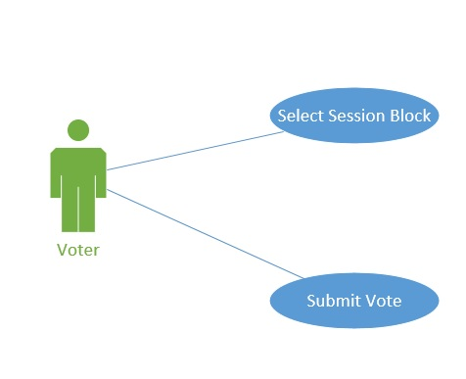

Select Session Block

Brief Description
Voter can select the desired session from the session blocks page.

Basic Flow of Events

Voter look for the session that he\she attended or any session he wants.
There would be sessions with 4 films in each, and Voter has to look for the session where the films he wants to vote for is at. He can look for one session or more than one.

Select the desired sessions.
Once the voter finds the sessions that he wants to vote in, he proceed to the next phase.

Alternative Flows

Voter can’t find the session block he wants.

A1. There are few reason voter could not find the session he wants. He might thought that he could look for a session that he attended yesterday or since there are several session he hasn’t gone through the whole session page.

Subflows
None

Key Scenarios

Success scenarios
Voter is able to find the desired section and all the films he watched are in the correct session blocks.-basic flow.

Failure scenarios
Voter won’t be able to vote for a film he watched on the last session yesterday- Alternative flow A1

Preconditions
Admin successfully loads all films informations in their respective sessions.

Postconditions
Voter has made his mind on how many session he wants to vote in.

Extension Points
None

Special Requirements
None

Additional Information
None

Submit Vote

Brief Description
Voter choose the desired film on one session or few session and submit his vote or votes for the films.

Basic Flow of Events

Voter chooses the desired film.
Voter chooses one film or many films in their respective session blocks.

Voter click on the radio button.
In each session there are four films, each films has a radio button below and voter chooses a film clicking on a radio button.

Voter submits his vote clicking the submit button

Once Voter picks the film he wants to vote for by clicking the radio button below it, he can submit his vote clicking on the submit button.

Session greys out

Once a vote is submitted that session greys out since Voter can only vote for one film per session.

Voter can repeat steps 1 to 4.
Voter is able to repeat steps 1 to 4 in different sessions where Voter would like to vote for specific films.

Alternative Flows

Voter wants to vote for two films.

A1. Voter might attended to a session where two films out of the four he watched, he would like to vote for. He probably would not be able to vote for two films in the same session, unless Admin allows it.

Subflow
None

Key Scenarios

Success scenarios
Voter successfully submits his vote for the desired films in several session with no problem at all.-basic flow

Failure scenarios
Voter want to vote for two films in the same session, but Admin won’t allow to do so. - Alternative flow A1

Preconditions
Voter has made his mind and chose sessions where he wants to vote.

Postconditions
Voter submitted vote and system stores vote in the database and automatically displays it on the leaderboard. Now, admin can pull date and make his reports.

Extension Points
None

Special Requirements
None

Additional Information
None

